1. Explain the communication flow between a DHCP client and server on a network that has two DHCP servers.
2. What is the smallest subnet size that would accommodate 7 hosts?
3. Ping use which protocol, the protocol is on which layer of TCP/IP model?
4. 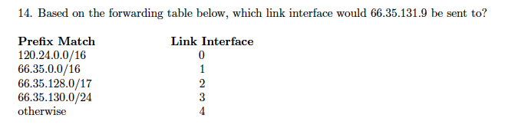
5. Bridge, router, switch, hub are on which layer of OSI model respectively?
6. What is the size of a MAC address? What is the size of a IP address?